BDSH Foremost Report – EIGHT.dd
Contents
Report 1
Files 1
JPG 1
GIF 1
00038731.gif 1
00038735.gif 2
00038807.gif 2
00038808.gif 2
OLE 2
ZIP 2
PNG 2
PDF 2

Report

44 FILES EXTRACTED
jpg:= 12
gif:= 4
ole:= 5
zip:= 4
png:= 18
pdf:= 1

Files

JPG

00000552.jpg
Appears to be a low quality image of a cruise ship on the water.
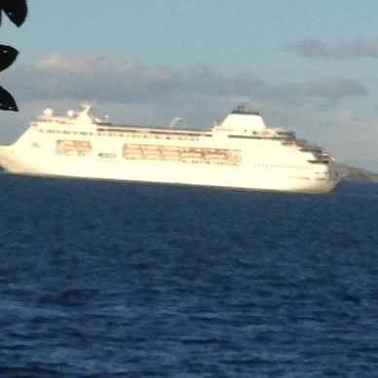

00001840.jpg
Appears to be a cat lying stretched out between two rafters of a ceiling.
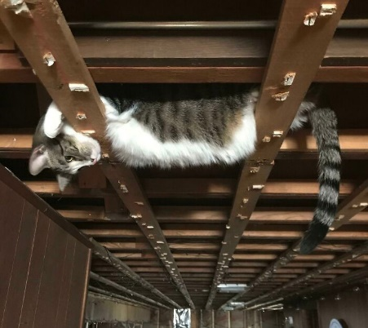

0000224.jpg
Appears to be a burned out power board.
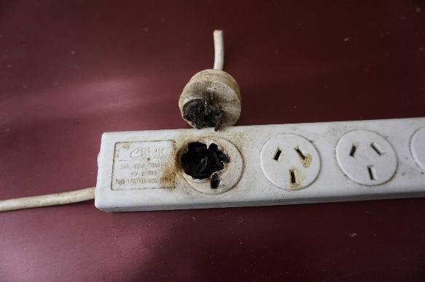

00004289.jpg
Appears to be an old black and white photograph of a school class, or possibly sports team.
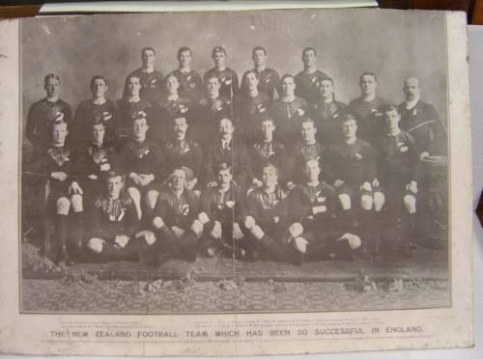

00004372.jpg
Appears to be a low quality image of a woman wearing a yellow bikini.


00004383.jpg
Appears to be the same image as 00004372.jpg, but with a pink square of corruption on it.


00004511.jpg
Appears to be the Sydney Opera house, but with a red lining and insignia decorations.
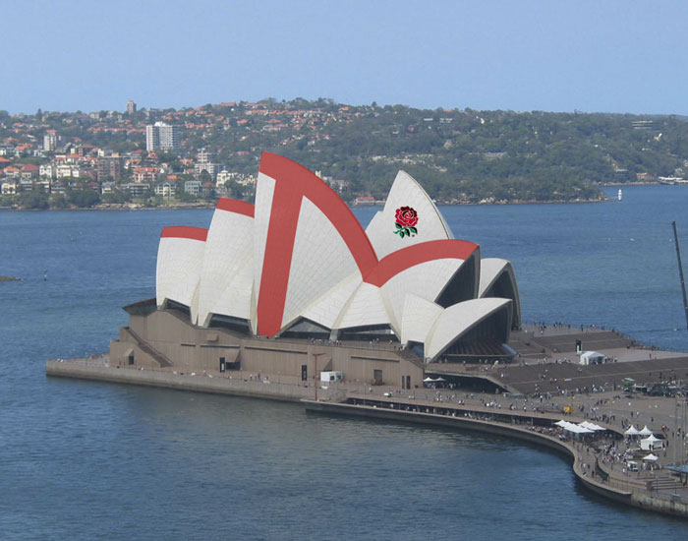

00004659.jpg
Appears to be a man at the pool wearing black swimming trunks.


00004712.jpg
Appears to be two men at the pool, wearing swimming togs.
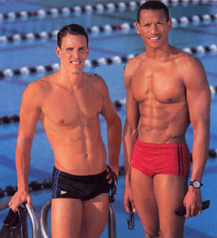

00004787.jpg
Appears to be a low quality photo of a group of people wearing swimming outfits.


00004864.jpg
Appears to be a photo of a street intersection taken from an outside café table.
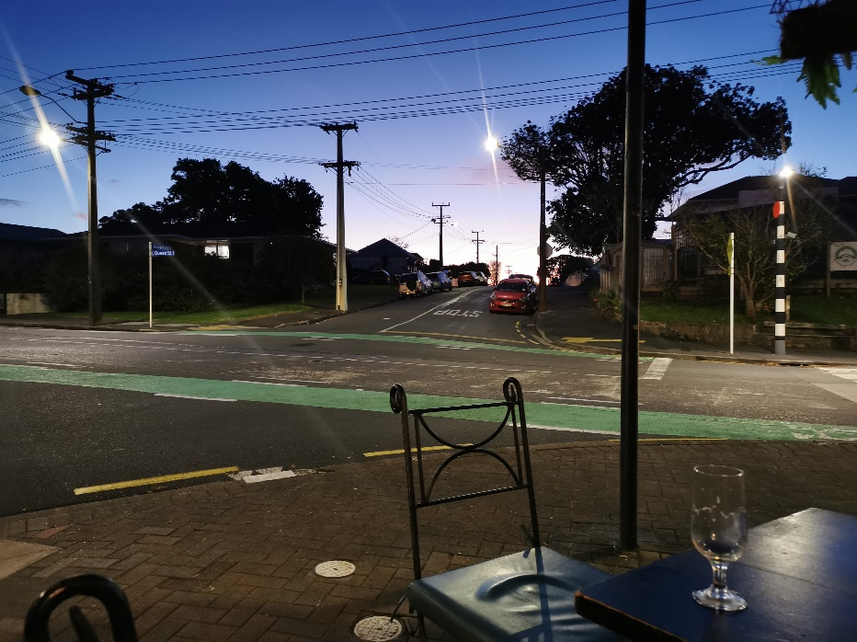

00010512.jpg
Appears to be a photo of an electronic thermometer displaying 990 degrees, however other text on the screen indicates that it is likely 066 degrees and is being held upside down.
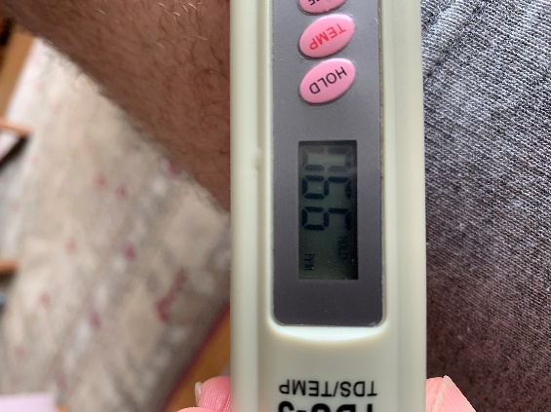

GIF

00038731.gif
Appears to be a woman holding her hand up to the sky, backlit by a sunset.


00038735.gif
Appears to be the same as 00038731.gif

00038807.gif
Appears to be a section of a header or possibly a game asset.


00038808.gif
Appears to be the same image as 00038807.gif.

OLE

000042000.ole
Contains the text “Hidden 1 Where is the hidden message in this document?” Below, the words “OK you found me” is repeated 15 times in white text, hidden against the white background.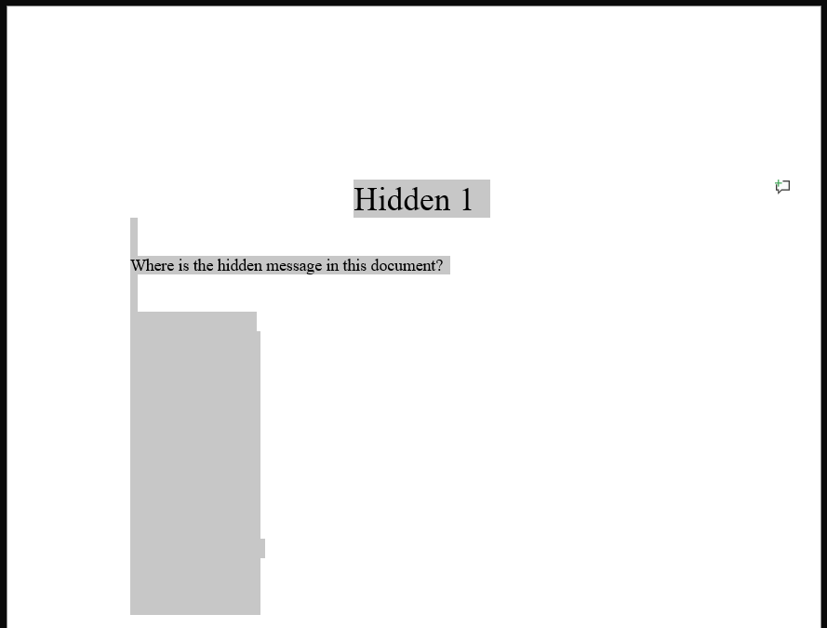

00004240.ole
Contains the text “Hidden 2 Where is the hidden message in this document?” Below, the words “OK you found me” is repeated 15 times, hidden behind a white image. 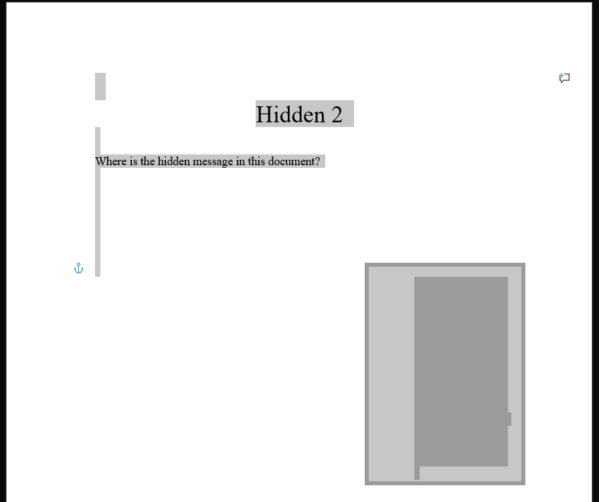

00004280.ole
Contains the text “Hidden 3 Where is the hidden message in this document”.
The image 00004289.jpg is present, shrunken down to the point where it appears to be the full stop at the end of the sentence.
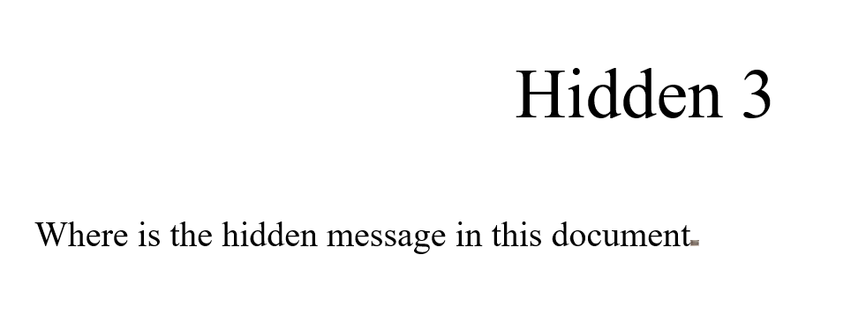

00004368.ole
Spreadsheet containing a person’s exam results. Scrolling down to line 2650 reveals a higher quality version of 00004372.jpg.
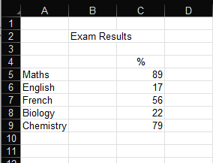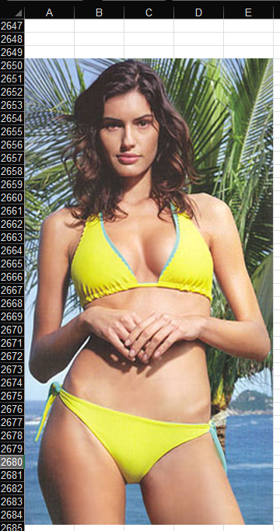

00004504.ole
Contains the text “Hidden 5 Hey this is a great picture of what the Aussies had to do to the Sydney Opera House when they lost to the English.” Below is 00004511.jpg. Hidden behind the image are images 00004659.jpg, 00004712.jpg, 00004787.jpg, and 00004806.png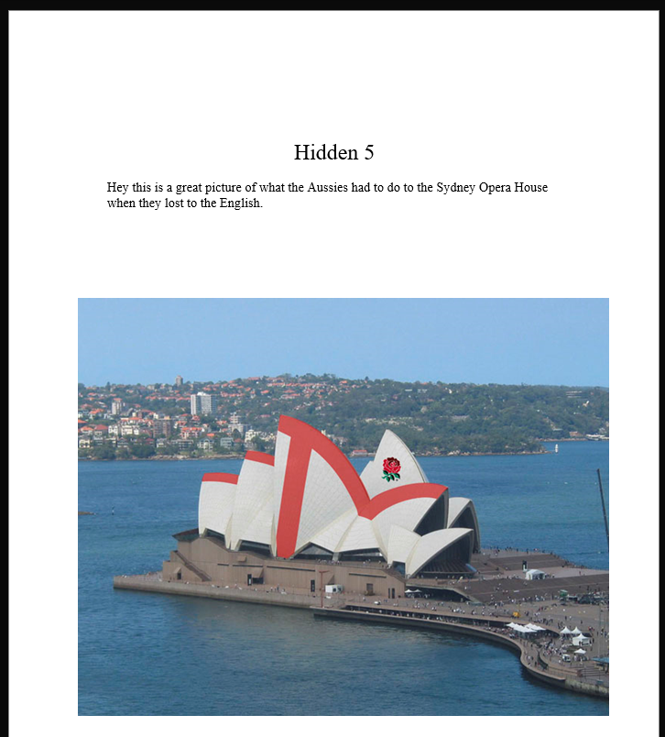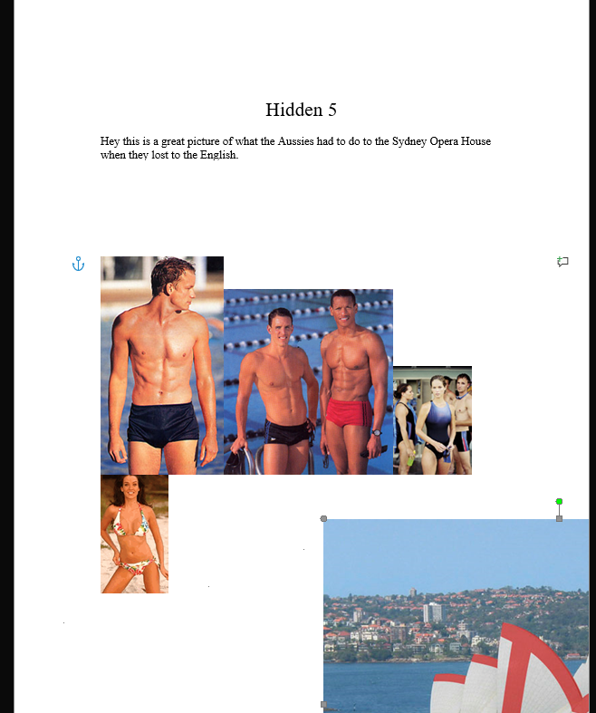

ZIP

PNG

PDF

